**Problem set 1:**

**BQ1**

**SELECT W_JOB_F.Location_ID**

**,Location_Name**

**,W_SALES_CLASS_D.Sales_class_id**

**,Sales_Class_Desc**

**,Time_Year**

**,Time_Month**

**,Base_price**

**,SUM(Quantity_Ordered) AS SUMQTY**

**,SUM(Quantity_Ordered * Unit_Price) AS Job_Amount**

**FROM W_JOB_F**

**,W_LOCATION_D**

**,W_SALES_CLASS_D**

**,W_TIME_D**

**WHERE W_JOB_F.Location_ID = W_LOCATION_D.Location_ID**

**AND W_JOB_F.Sales_class_id = W_SALES_CLASS_D.Sales_class_id**

**AND W_TIME_D.Time_id = W_JOB_F.Contract_date**

**GROUP BY W_JOB_F.Location_ID**

**,Location_Name**

**,W_SALES_CLASS_D.Sales_class_id**

**,Sales_Class_Desc**

**,Time_Year**

**,Time_Month**

**,Base_price;**

Result: 1705 rows

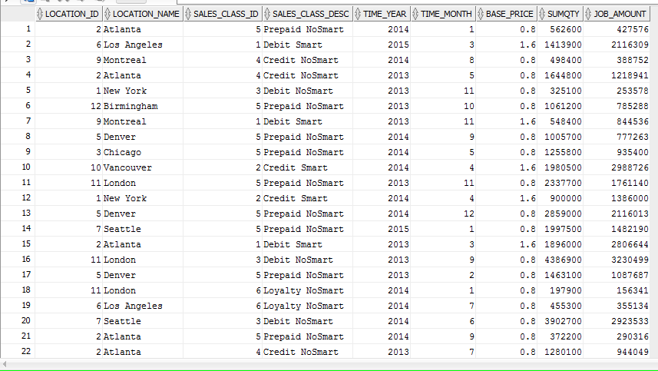

**BQ2**

**SELECT W_JOB_F.JOB_ID**

**,W_JOB_F.Location_ID**

**,W_Location_D.Location_Name**

**,Unit_Price**

**,Quantity_Ordered**

**,Time_Year**

**,Time_Month**

**,SUM(Invoice_Amount) AS SUMINVAMT**

**,SUM(Invoice_Quantity) AS SUMINVQTY**

**FROM W_JOB_F**

**,W_LOCATION_D**

**,W_TIME_D**

**,W_INVOICELINE_F**

**,W_SUB_JOB_F**

**,W_JOB_SHIPMENT_F**

**WHERE W_JOB_F.Location_ID = W_LOCATION_D.Location_ID**

**AND W_TIME_D.Time_id = W_JOB_F.Contract_date**

**AND W_Job_Shipment_F.Invoice_Id = W_InvoiceLine_F.Invoice_Id**

**AND W_JOB_F.Job_Id = W_SUB_JOB_F.Job_Id**

**AND W_JOB_SHIPMENT_F.Sub_Job_Id = W_Sub_Job_F.Sub_Job_Id**

**GROUP BY W_JOB_F.JOB_ID**

**,W_JOB_F.Location_ID**

**,W_Location_D.Location_Name**

**,Unit_Price**

**,Quantity_Ordered**

**,Time_Year**

**,Time_Month;**

**CREATE VIEW BQ2**

**AS**

**SELECT W_JOB_F.JOB_ID**

**,W_JOB_F.Location_ID**

**,W_Location_D.Location_Name**

**,Unit_Price**

**,Quantity_Ordered**

**,Time_Year**

**,Time_Month**

**,SUM(Invoice_Amount) AS SUMINVAMT**

**,SUM(Invoice_Quantity) AS SUMINVQTY**

**FROM W_JOB_F**

**,W_LOCATION_D**

**,W_TIME_D**

**,W_INVOICELINE_F**

**,W_SUB_JOB_F**

**,W_JOB_SHIPMENT_F**

**WHERE W_JOB_F.Location_ID = W_LOCATION_D.Location_ID**

**AND W_TIME_D.Time_id = W_JOB_F.Contract_date**

**AND W_Job_Shipment_F.Invoice_Id = W_InvoiceLine_F.Invoice_Id**

**AND W_JOB_F.Job_Id = W_SUB_JOB_F.Job_Id**

**AND W_JOB_SHIPMENT_F.Sub_Job_Id = W_Sub_Job_F.Sub_Job_Id**

**GROUP BY W_JOB_F.JOB_ID**

**,W_JOB_F.Location_ID**

**,W_Location_D.Location_Name**

**,Unit_Price**

**,Quantity_Ordered**

**,Time_Year**

**,Time_Month;**

Result: 2504 rows

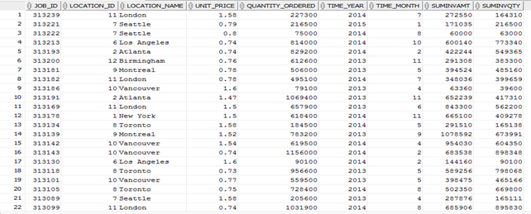

**BQ3**

**CREATE VIEW BQ3**

**AS**

**SELECT JOB_ID**

**,Location_ID**

**,Location_Name**

**,Time_Year**

**,Time_Month**

**,SUMLABOUR**

**,SUMMATERIAL**

**,SUMOVERHEAD**

**,SUMMACHINE**

**,SUMQTY**

**,TOTALCOST**

**,TOTALCOST / SUMQTY AS UNIT_PRICE**

**FROM (**

**SELECT W_SUB_JOB_F.JOB_ID**

**,W_SUB_JOB_F.Location_ID**

**,Location_Name**

**,Time_Year**

**,Time_Month**

**,SUM(Cost_Labor) AS SUMLABOUR**

**,SUM(Cost_Material) AS SUMMATERIAL**

**,SUM(Cost_Overhead) AS SUMOVERHEAD**

**,SUM(Machine_Hours * Rate_per_hour) AS SUMMACHINE**

**,SUM(Quantity_produced) AS SUMQTY**

**,SUM(Cost_Labor + Cost_Material + Cost_Overhead + Machine_Hours * Rate_per_hour) AS TOTALCOST**

**FROM W_SUB_JOB_F**

**,W_JOB_F**

**,W_TIME_D**

**,W_LOCATION_D**

**,W_MACHINE_TYPE_D**

**WHERE W_SUB_JOB_F.Job_id = W_JOB_F.Job_id**

**AND W_location_d.location_id = W_SUB_JOB_F.Location_id**

**AND W_Time_D.Time_id = W_Job_F.Contract_Date**

**AND W_SUB_JOB_F.Machine_Type_id = W_Machine_Type_D.Machine_Type_ID**

**GROUP BY W_SUB_JOB_F.JOB_ID**

**,W_SUB_JOB_F.Location_ID**

**,Location_Name**

**,Time_Year**

**,Time_Month**

**);**

Result: 2527 rows

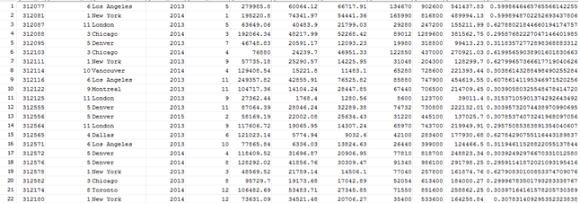

**BQ4**

**SELECT W_InvoiceLine_F.Location_Id**

**,Location_Name**

**,W_InvoiceLine_F.Sales_Class_Id**

**,Sales_Class_Desc**

**,Time_Year**

**,Time_Month**

**,SUM(Quantity_shipped - Invoice_Quantity) AS QTYRETURNED**

**,SUM((Quantity_shipped - Invoice_quantity) * (Invoice_amount / Invoice_quantity)) AS SUMAMTRETURNED**

**FROM W_INVOICELINE_F**

**,W_Location_D**

**,W_Sales_Class_D**

**,W_TIME_D**

**WHERE quantity_shipped - invoice_quantity > 0**

**AND W_INVOICELINE_F.INVOICE_SENT_DATE = W_TIME_D.TIME_ID**

**AND W_INVOICELINE_F.Location_Id = W_Location_D.Location_Id**

**AND W_INVOICELINE_F.Sales_Class_Id = W_Sales_Class_D.Sales_Class_Id**

**GROUP BY W_InvoiceLine_F.Location_Id**

**,Location_Name**

**,W_InvoiceLine_F.Sales_Class_Id**

**,Sales_Class_Desc**

**,Time_Year**

**,Time_Month;**

Result: 1159 rows

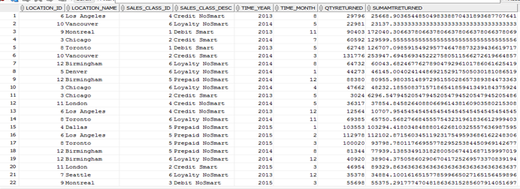

**BQ5**

**SELECT Job_id**

**,Location_ID**

**,Location_Name**

**,Sales_class_id**

**,sales_class_desc**

**,Date_Promised**

**,Quantity_Ordered**

**,LastShipDate**

**,SUMSHIPQTY**

**,getBusDaysDiff(LastShipDate, Date_Promised) AS DaysDiff**

**FROM (**

**SELECT W_JOB_F.Job_id**

**,W_JOB_F.Location_ID**

**,Location_Name**

**,W_JOB_F.Sales_class_id**

**,sales_class_desc**

**,Date_Promised**

**,Quantity_Ordered**

**,MAX(Actual_Ship_Date) AS LastShipDate**

**,SUM(Actual_Quantity) AS SUMSHIPQTY**

**FROM W_JOB_F**

**,W_LOCATION_D**

**,W_SALES_CLASS_D**

**,W_SUB_JOB_F**

**,W_JOB_SHIPMENT_F**

**WHERE Actual_Ship_Date > Date_Promised**

**AND W_JOB_F.Location_id = W_LOCATION_D.Location_id**

**AND W_Job_F.Sales_Class_Id = W_Sales_Class_D.Sales_Class_Id**

**AND W_SUB_JOB_F.SUB_JOB_ID = W_JOB_SHIPMENT_F.SUB_JOB_ID**

**AND W_Job_F.Job_Id = W_SUB_JOB_F.JOB_ID**

**GROUP BY W_JOB_F.Job_id**

**,W_JOB_F.Location_ID**

**,Location_Name**

**,W_JOB_F.Sales_class_id**

**,sales_class_desc**

**,Date_Promised**

**,Quantity_Ordered**

**)**

**WHERE LastShipDate > Date_Promised;**

**CREATE VIEW BQ5**

**AS**

**SELECT Job_id**

**,Location_ID**

**,Location_Name**

**,Sales_class_id**

**,sales_class_desc**

**,Date_Promised**

**,Quantity_Ordered**

**,LastShipDate**

**,SUMSHIPQTY**

**,getBusDaysDiff(LastShipDate, Date_Promised) AS DaysDiff**

**FROM (**

**SELECT W_JOB_F.Job_id**

**,W_JOB_F.Location_ID**

**,Location_Name**

**,W_JOB_F.Sales_class_id**

**,sales_class_desc**

**,Date_Promised**

**,Quantity_Ordered**

**,MAX(Actual_Ship_Date) AS LastShipDate**

**,SUM(Actual_Quantity) AS SUMSHIPQTY**

**FROM W_JOB_F**

**,W_LOCATION_D**

**,W_SALES_CLASS_D**

**,W_SUB_JOB_F**

**,W_JOB_SHIPMENT_F**

**WHERE Actual_Ship_Date > Date_Promised**

**AND W_JOB_F.Location_id = W_LOCATION_D.Location_id**

**AND W_Job_F.Sales_Class_Id = W_Sales_Class_D.Sales_Class_Id**

**AND W_SUB_JOB_F.SUB_JOB_ID = W_JOB_SHIPMENT_F.SUB_JOB_ID**

**AND W_Job_F.Job_Id = W_SUB_JOB_F.JOB_ID**

**GROUP BY W_JOB_F.Job_id**

**,W_JOB_F.Location_ID**

**,Location_Name**

**,W_JOB_F.Sales_class_id**

**,sales_class_desc**

**,Date_Promised**

**,Quantity_Ordered**

**)**

**WHERE LastShipDate > Date_Promised;**

Result: 71 rows

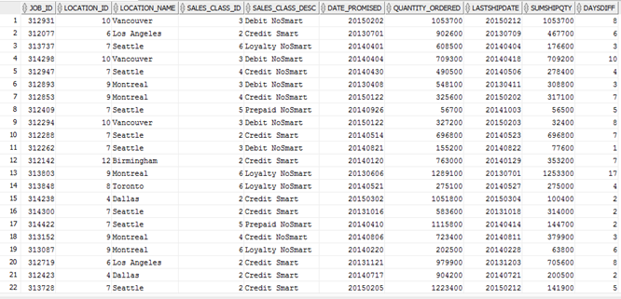

**BQ6**

**SELECT Job_id**

**,Location_ID**

**,Location_Name**

**,Sales_class_id**

**,sales_class_desc**

**,Date_Ship_By**

**,FirstShipDate**

**,getBusDaysDiff(FirstShipDate, Date_Ship_By) AS DaysDiff**

**FROM (**

**SELECT W_JOB_F.Job_id**

**,W_JOB_F.Location_ID**

**,Location_Name**

**,W_JOB_F.Sales_class_id**

**,sales_class_desc**

**,Date_Ship_By**

**,MIN(Actual_Ship_Date) AS FirstShipDate**

**FROM W_JOB_F**

**,W_LOCATION_D**

**,W_SALES_CLASS_D**

**,W_SUB_JOB_F**

**,W_JOB_SHIPMENT_F**

**WHERE W_JOB_F.Location_id = W_LOCATION_D.Location_id**

**AND W_Job_F.Sales_Class_Id = W_Sales_Class_D.Sales_Class_Id**

**AND W_SUB_JOB_F.SUB_JOB_ID = W_JOB_SHIPMENT_F.SUB_JOB_ID**

**AND W_Job_F.Job_Id = W_SUB_JOB_F.JOB_ID**

**GROUP BY W_JOB_F.Job_id**

**,W_JOB_F.Location_ID**

**,Location_Name**

**,W_JOB_F.Sales_class_id**

**,sales_class_desc**

**,Date_Ship_By**

**)**

**WHERE FirstShipDate > Date_Ship_By;**

**CREATE VIEW BQ6**

**AS**

**SELECT Job_id**

**,Location_ID**

**,Location_Name**

**,Sales_class_id**

**,sales_class_desc**

**,Date_Ship_By**

**,FirstShipDate**

**,getBusDaysDiff(FirstShipDate, Date_Ship_By) AS DaysDiff**

**FROM (**

**SELECT W_JOB_F.Job_id**

**,W_JOB_F.Location_ID**

**,Location_Name**

**,W_JOB_F.Sales_class_id**

**,sales_class_desc**

**,Date_Ship_By**

**,MIN(Actual_Ship_Date) AS FirstShipDate**

**FROM W_JOB_F**

**,W_LOCATION_D**

**,W_SALES_CLASS_D**

**,W_SUB_JOB_F**

**,W_JOB_SHIPMENT_F**

**WHERE W_JOB_F.Location_id = W_LOCATION_D.Location_id**

**AND W_Job_F.Sales_Class_Id = W_Sales_Class_D.Sales_Class_Id**

**AND W_SUB_JOB_F.SUB_JOB_ID = W_JOB_SHIPMENT_F.SUB_JOB_ID**

**AND W_Job_F.Job_Id = W_SUB_JOB_F.JOB_ID**

**GROUP BY W_JOB_F.Job_id**

**,W_JOB_F.Location_ID**

**,Location_Name**

**,W_JOB_F.Sales_class_id**

**,sales_class_desc**

**,Date_Ship_By**

**)**

**WHERE FirstShipDate > Date_Ship_By;**

Result: 87 rows

